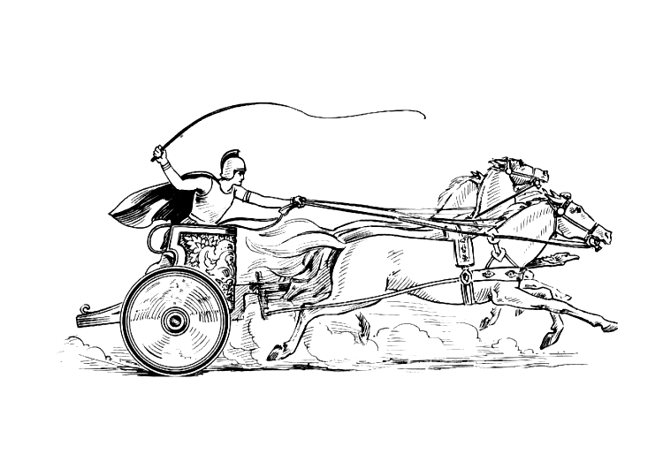
Manduessedum - Mancetter Village
(Place of War Chariots) Wishing you A Merry Christmas
and a Happy and Healthy 2022.
Mancetter Parish Council
Serving the People of Mancetter and Ridge Lane.
01827 722552 parishclerk@mancetter.org.uk www.mancetter.org.uk

It is lovely to once again be part of a parish wide edition of “Mancetter Matters” .
A lot of things have changed over the last 18 months, and it is clearer than ever before that local people working together to support our community and our environment is so important.

Next year in June, both villages will be commemorating the Queen’s Platinum Jubilee. St Peter’s Church, Mancetter Memorial Hall, Ridge Lane Chapel and The Brewery Tap are the venues that will be supporting local community groups, and each other, to host a range of activities over the bank holiday weekend for adults and children. The Parish Council will be helping to co-ordinate events and also provide some funding. If you wish to be part of this or join as a councillor then please get in touch.

This year Eagledale, a locally based company who specialise in architectural metalwork, have worked alongside the parish council and our contractors, and together we have restored the cemetery railings back to their original condition. The parish council will also be planting some specialist trees in the cemetery to help with the water table.

Parish councillors have been discussing with various agencies about replacing the signage into each village to reflect our roman and industrial heritage. Ridge Lane is proud of its coal mining background and Roman Mancetter has a fantastic Heritage Centre situated in St Peter’s Church. The idea is to install gated entrances with floral displays to try to deter speed, encourage wildlife and help to put our beautiful villages on the map.

